PROJECT REPORT

Estimation and prediction of Hospitalization and medical care costs

TEAM MEMBERS

**Team id**: LTVIP2023TMID08280

**Team members:**

**Team Leader :** G.NagaSai Kumar

**Team member :** C.Sameera Anjum

**Team member :** Dasari uday kiran

**Team member :** D.charan Kumar reddy

**Team member :** Diguvinti Chakala Naveen

**Estimation And Prediction Of Hospitalization And Medical Care Costs**

Medical costs are one of the most common recurring expenses in a person's life. Based on different research studies, BMI, ageing, smoking, and other factors are all related to greater personal medical care costs. The estimates of the expenditures of health care related to obesity are needed to help create cost-effective obesity prevention strategies. Obesity prevention at a

Young age is a top concern in global health, clinical practice, and public health.

**Project Flow**

**Project Flow**

To accomplish this, we have to complete all the activities listed below,

* Define Problem / Problem Understanding
  + Specify the business problem
  + Business requirements
  + Literature Survey
  + Social or Business Impact.
* Data Collection & Extraction from Database
  + Collect the dataset,
  + Connect IBM DB2 with IBM Cognos
* Data Preparation
  + Prepare the Data for Visualization
* Data Visualizations
  + No of Unique Visualizations
* Dashboard
  + Responsive and Design of Dashboard
* Story
  + No of Scenes of Story
* Report
  + Creating a Report
* Performance Testing
  + Amount of Data Rendered to DB ‘
  + Utilization of Data Filters
  + No of Calculation Fields
  + No of Visualizations/ Graphs
* Web Integration
  + Dashboard and Story embed with UI With Flask
* Project Demonstration & Documentation
  + Record explanation Video for project end-to-end solution
  + Project Documentation-Step by step project development procedure
* **Define Problem / Problem Understanding**
* A problem statement is a clear and concise description of the issue or challenge that needs to be addressed. It should define the problem in a way that is understandable to stakeholders and provide a basis for developing a solution or course of action.
* Identifying the Problem: The first step is to identify the problem or the issue that needs to be addressed. This requires recognizing the gap between the current state and the desired state or understanding what obstacles are hindering progress.
* Defining the Problem Scope: Once the problem is identified, it's important to establish the boundaries and limitations of the problem. This helps in focusing efforts on the core issue and prevents unnecessary distractions.
* Gathering Information: Thorough research and data collection are essential in understanding the problem fully. This may involve gathering data, conducting interviews, consulting experts, reviewing relevant literature, or using other information-gathering techniques.
* Analyzing the Problem: The collected information needs to be analyzed to gain insights into the root causes, contributing factors, and potential implications of the problem. Analyzing the problem helps in identifying patterns and relationships that can aid in finding effective solutions.
* Stakeholder Identification: Identifying and involving relevant stakeholders is crucial. Stakeholders are individuals or groups who have an interest in or are affected by the problem and its potential solutions. Their perspectives and input can provide valuable context and aid in finding feasible solutions.
* Understanding Constraints and Requirements: It's essential to understand any constraints, limitations, or requirements that must be considered when formulating potential solutions. These could be related to budget, time, resources, regulations, or other practical considerations.
* Problem Statement: The problem understanding phase culminates in crafting a clear and concise problem statement. The problem statement should define the problem, its context, the desired outcomes, and any constraints that need to be considered. It serves as a guiding document for the subsequent stages of problem-solving.

**Specify the business problem**

* Refer Project Description
* As an AI language model, I do not have access to real-time data or information about specific events or situations beyond my last update in September 2021. Consequently, I am unaware of current events or any specific business problems that may have emerged after that date.
* To specify a business problem, you need to provide relevant context and details about the particular issue you are facing or interested in. Whether it's related to operations, marketing, finance, human resources, technology, or any other aspect of business, please provide the necessary information so I can better understand and assist with the problem at hand.
* **Business requirements**
* The business requirements for this project would likely include
* Data collection: The first requirement is to collect data from Kaggle which is relevant to medical care costs
* Data cleaning and preparation: The collected data must be cleaned and processed to ensure it is suitable for analysis. This may involve removing irrelevant information, correcting inconsistencies and missing values, and transforming the data into a format that is compatible with the analysis tools.
* Data analysis: The data must be analysed to uncover meaningful insights into the medical care cost market. This could involve using techniques such as descriptive statistics, regression analysis, and data visualization to gain a deeper understanding of the data.
* Report creation: The insights and findings from the data analysis must be presented in a comprehensive report that includes visualizations and data tables. The report must be well organized and easy to understand, with clear and concise explanations of the results

* **Literature Survey (Student Will Write)**
* The prevalence of obesity, which is defined as a body mass index (BMI) greater than 30, has increased dramatically in the United States since the late 1990s. So much so that recently obesity has been officially recognized as a disease by the American Medical Association, an action that could put more emphasis on the health condition by doctors and insurance companies to minimize its adverse effects. Currently, rates of obesity exceed 30% in most sex and adult age groups, whereas its prevalence among children and adolescents, defined as a BMI of more than the 95th percentile, has reached 17%.
* The alarming rates of the high prevalence of obesity have posed a significant public health concern as well as a substantial financial burden on our society because obesity is known to be a risk factor for many chronic diseases, such as type 2 diabetes, cancer, hypertension, asthma, myocardial infarction, stroke, and other conditions. To understand the economic burden of obesity, several studies have attempted to estimate the attributable costs of obesity, following the burden-of-illness literature on other disease areas. A previous cost-of-illness study estimated that healthcare spending attributable to the rising prevalence of obesity has increased by 27% between 1987 and 2001

* **Social or Business Impact.**
* Social Impact: Customers can make more informed decisions about their travel plans and compare prices and services more easily.
* Business Model/Impact: Competitive Advantage, Innovation and Improved Business strategy can be achieved by analysing

**Data Collection & Extraction From Database**

Data collection is the process of gathering and measuring information on variables of interest, in an established systematic fashion that enables one to answer stated research questions, test hypotheses, and evaluate outcomes and generate insights from the data.

**Data Preparation**

In this milestone, we will see how to prepare the data for building visualizations

**Prepare The Data For Visualization**

Preparing the data for visualization involves cleaning the data to remove irrelevant or missing data, transforming the data into a format that can be easily visualized, exploring the data to identify patterns and trends, filtering the data to focus on specific subsets of data, preparing the data for visualization software, and ensuring the data is accurate and complete. This process helps to make the data easily understandable and ready for creating visualizations to gain insights into the performance and efficiency.

**Data Visualization**

Data visualization is the process of creating graphical representations of data in order to help people understand and explore the information. The goal of data visualization is to make complex data sets more accessible, intuitive, and easier to interpret. By using visual elements such as charts, graphs, and maps, data visualizations can help people quickly identify patterns, trends, and outliers in the data.

**No Of Unique Visualizations**

The number of unique visualizations that can be created with a given dataset. Some common types of visualizations that can be used to analyze the performance and efficiency of Radisson Hotels include bar charts, line charts, heat maps, scatter plots, pie charts,Maps etc. These visualizations can be used to compare performance, track changes over time, show distribution, and relationships between variables, breakdown of revenue and customer demographics, workload, resource allocation and location of hotels.

**Dashboard**

A dashboard is a graphical user interface (GUI) that displays information and data in an organized, easy-to-read format. Dashboards are often used to provide real-time monitoring and analysis of data, and are typically designed for a specific purpose or use case. Dashboards can be used in a variety of settings, such as business, finance, manufacturing, healthcare, and many other industries. They can be used to track key performance indicators (KPIs), monitor performance metrics, and display data in the form of charts, graphs, and tables.

**Responsive And Design Of Dashboard**

The responsiveness and design of a dashboard for analysing the factors important for the analysis of medical care cost analysis are crucial to ensure that the information is easily understandable and actionable. Key considerations for designing a responsive and effective dashboard include user-centred design, clear and concise information, interactivity, data-driven approach, accessibility, customization, and security. The goal is to create a dashboard that is user-friendly, interactive, and data-driven, providing actionable insights

Once you have created views on different sheets in IBM Cognos, you can pin them and pull them into a dashboard.

**Note : The all above visualizations have created in the dashboard itself, kindly watch the above links**

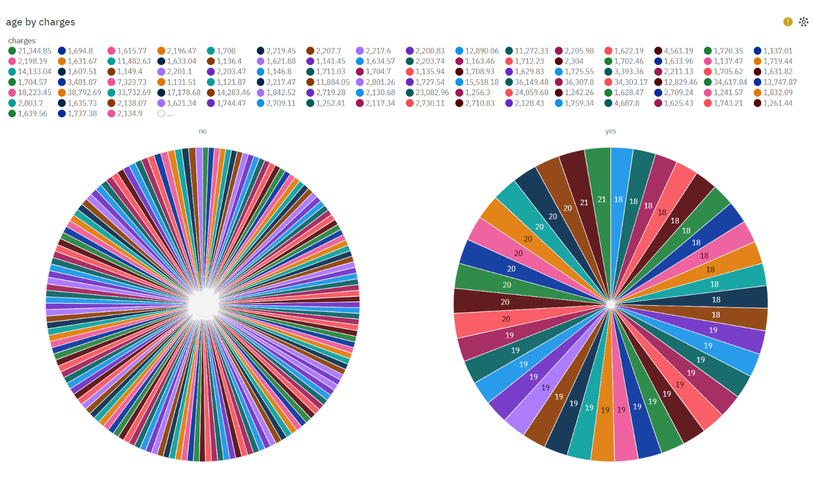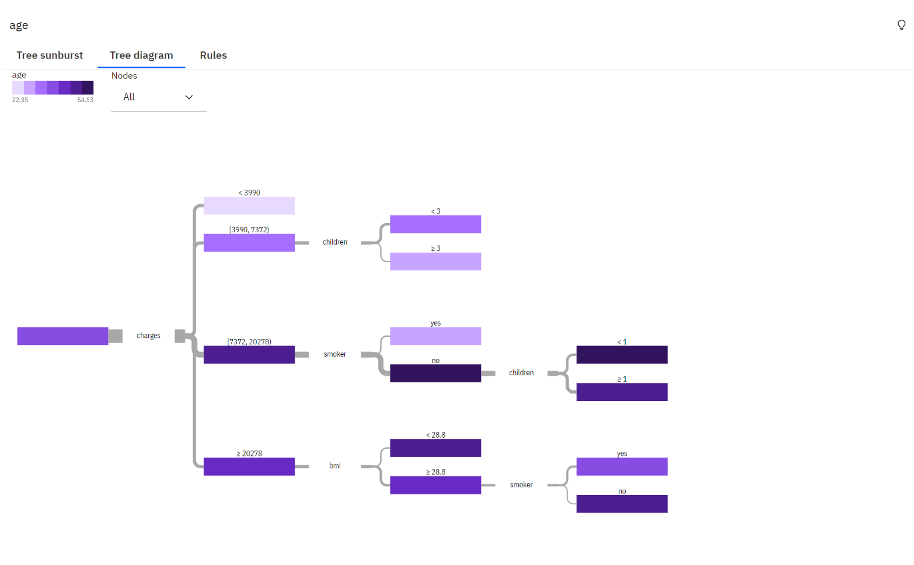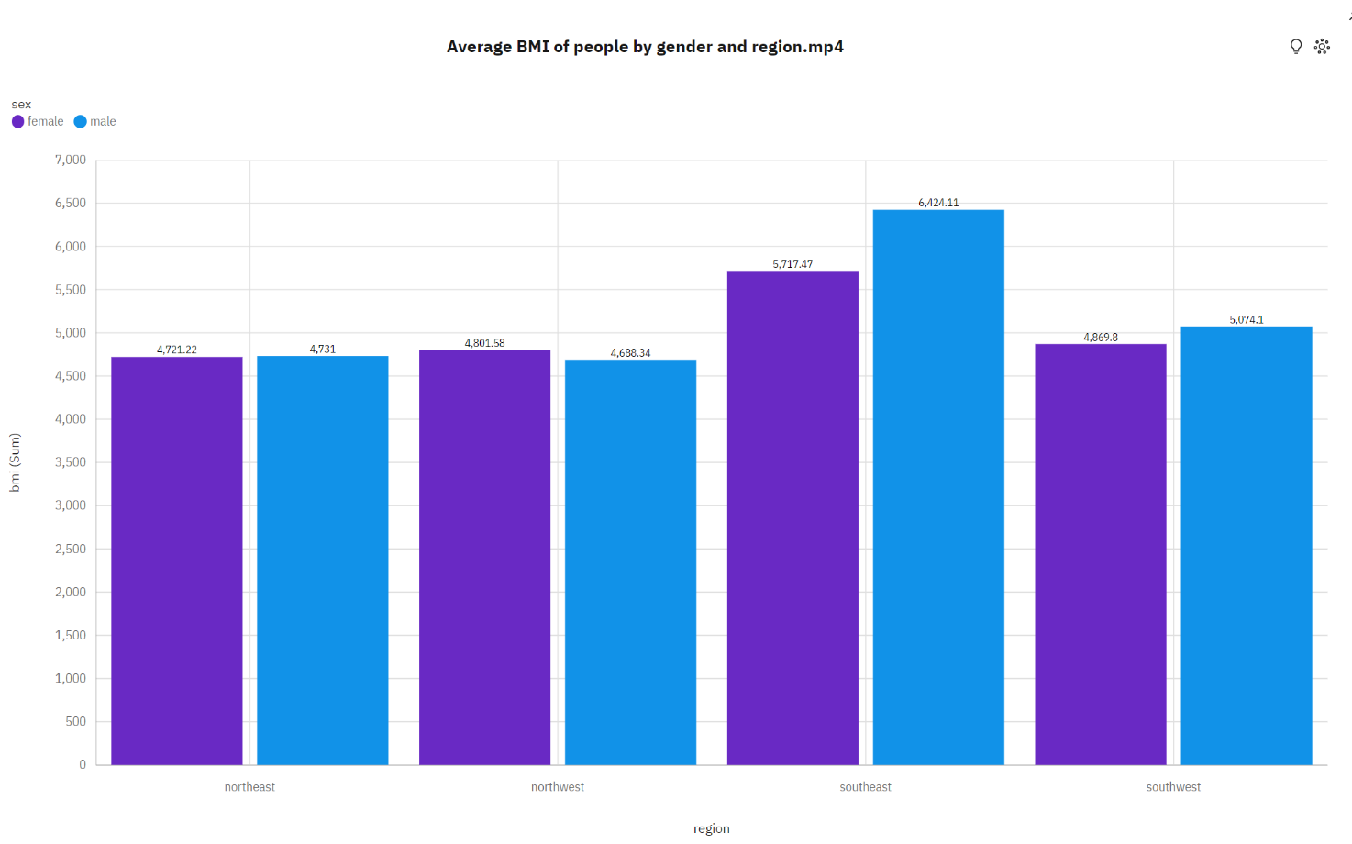

**Story**

A data story is a way of presenting data and analysis in a narrative format, with the goal of making the information more engaging and easier to understand. A data story typically includes a clear introduction that sets the stage and explains the context for the data, a body that presents the data and analysis in a logical and systematic way, and a conclusion that summarizes the key findings and highlights their implications. Data stories can be told using a variety of mediums, such as reports, presentations, interactive visualizations, and videos.

**No Of Scenes Of Story**

The number of scenes in a storyboard for a data visualization analysis of the factors affecting the selection of medical care costs will depend on the complexity of the analysis and the specific insights that are trying to be conveyed. A storyboard is a visual representation of the data analysis process and it breaks down the analysis into a series of steps or scenes.

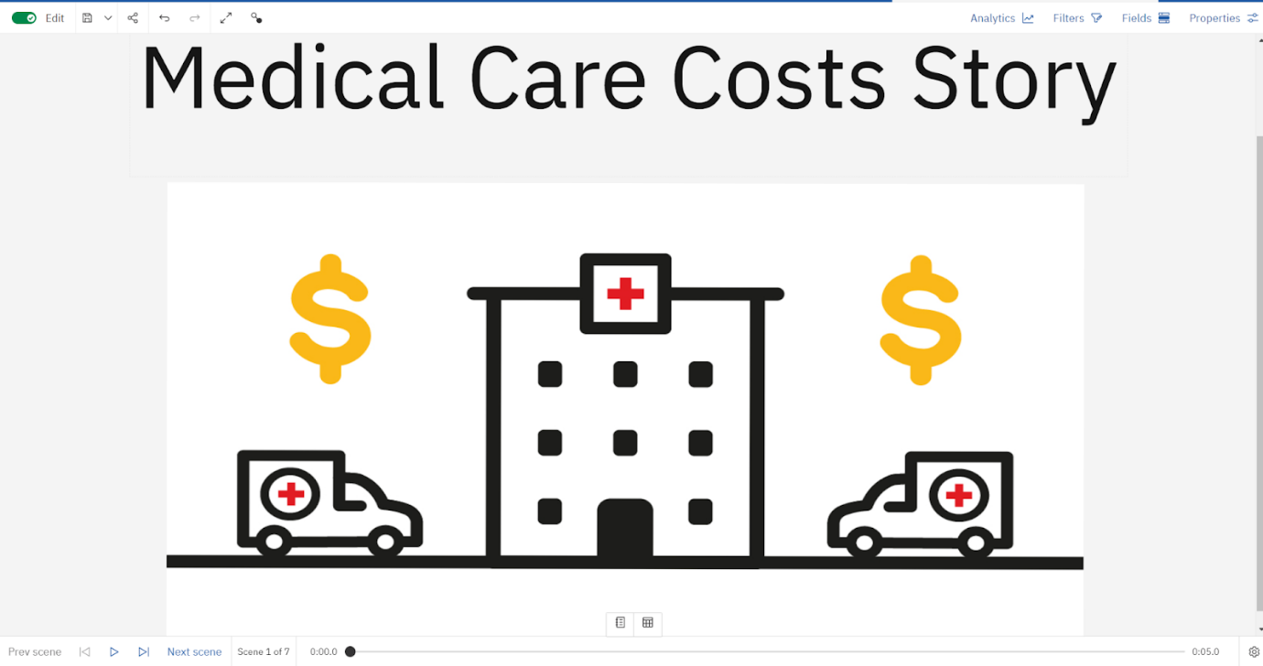

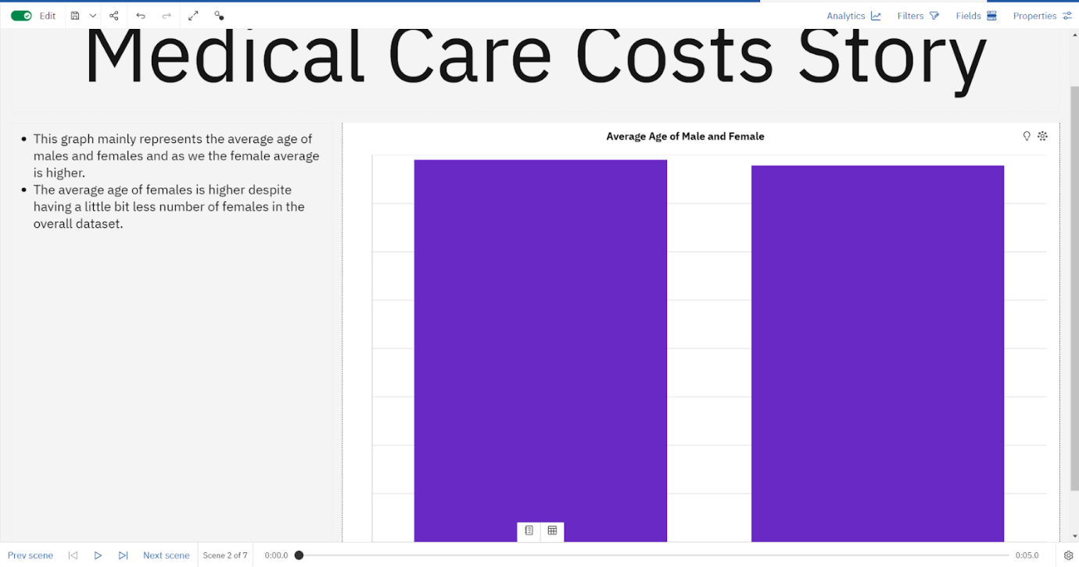

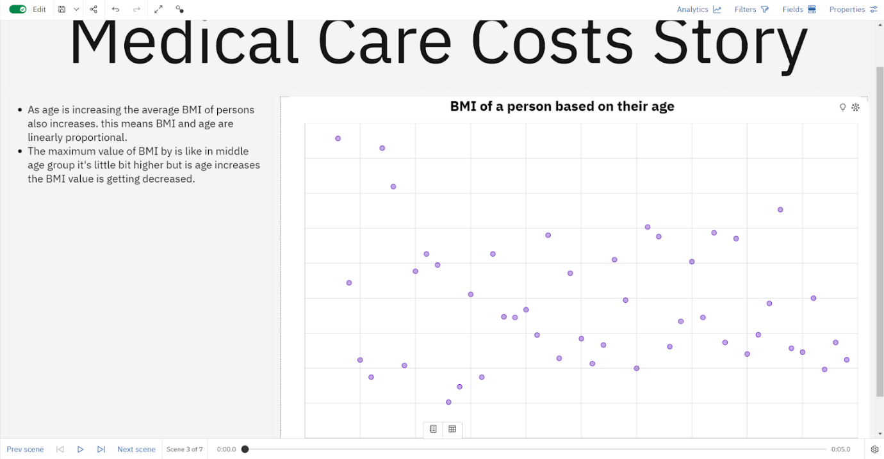

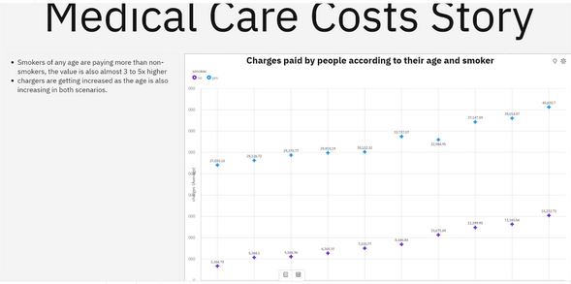

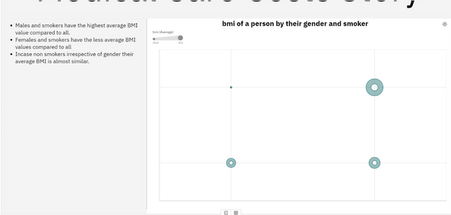

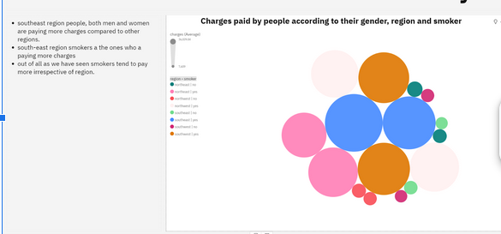

**Report**

A report is a document that presents information in a specific format and layout, usually based on data from a database or other data source. A report in IBM Cognos can contain various elements, such as tables, charts, graphs, and images, as well as text and data elements, and it is designed to be used by business users to help them better understand their data and make informed decisions. There are several different types of reports available in IBM Cognos, including list reports, crosstab reports, chart reports, and report studio reports, among others. The type of report that you choose will depend on the specific needs and requirements of your organization, as well as the data that you need to present.

**No Of Visualization With Detail Information**

When creating a report in cognos, it is often helpful to include visualizations to help communicate the findings of the analysis.

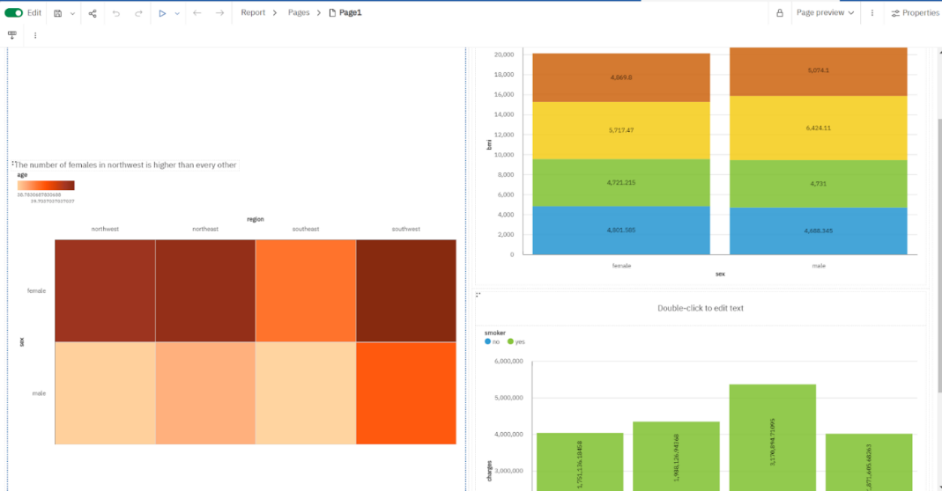

### Performance Testing

**Amount Of Data Rendered To DB2**

The amount of data that is rendered to a database depends on the size of the dataset and the capacity of the database to store and retrieve data.

**Utilization Of Data Filters**

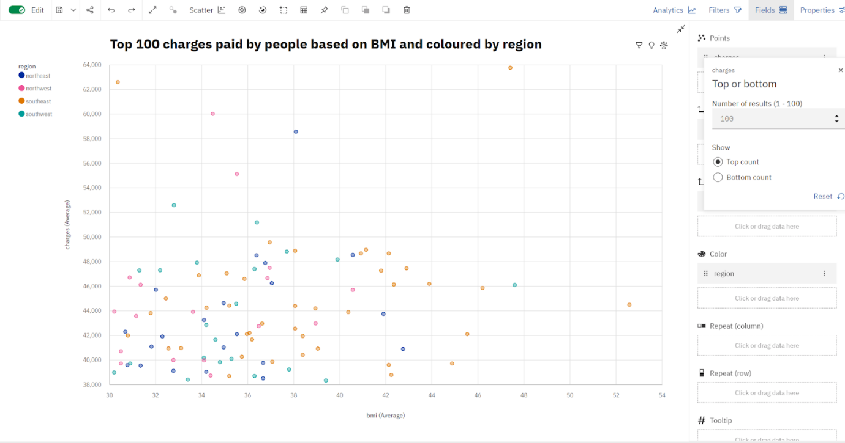

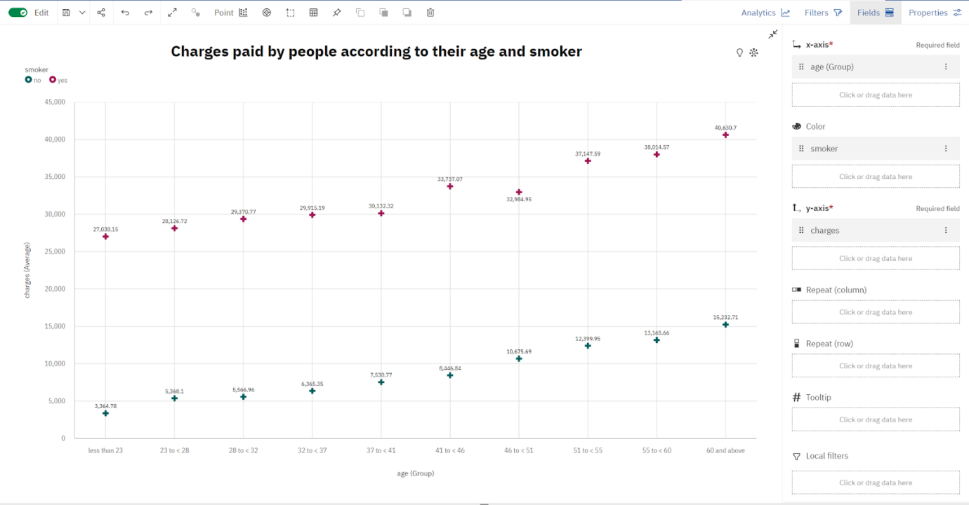

**No Of Calculation Fields**

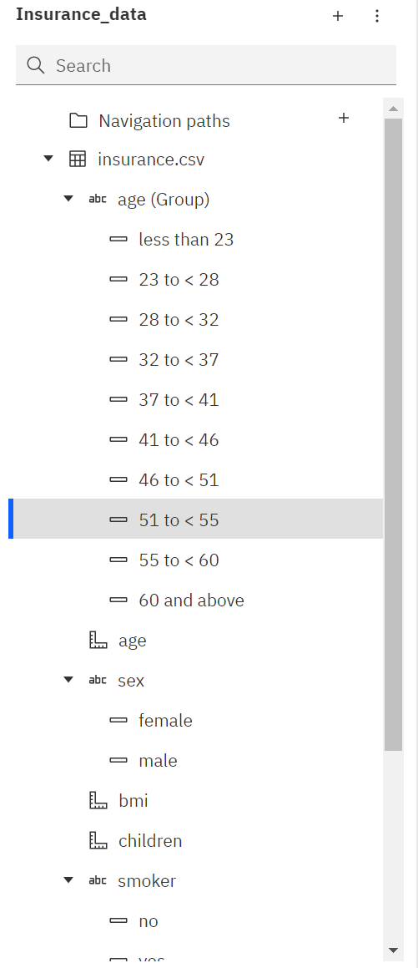

**No Of Visualizations/ Graphs**

* Average Age of Male and Female
* Bmi of a person by age
* Number of children by age and smoker
* The average age of people according to their region and gender
* Charges paid by people according to their age and smoker
* BMI of a person by their gender and smoker
* Charges paid by people according to their gender, region and smoker
* Average BMI of people by gender and region
* Top 100 charges paid by people based on BMI and coloured by region
* Number of Children to the people by region
* Charges paid by the people by region
* Charges based on the number of children

**Web Integration**

Publishing helps us to track and monitor key performance metrics, to communicate results and progress. help a publisher stay informed, make better decisions, and communicate their performance to others.

**Publishing dashboard,report & story.**

Step 1: Go to Dashboard,report & /story, click on share button on the top.

Dashboard

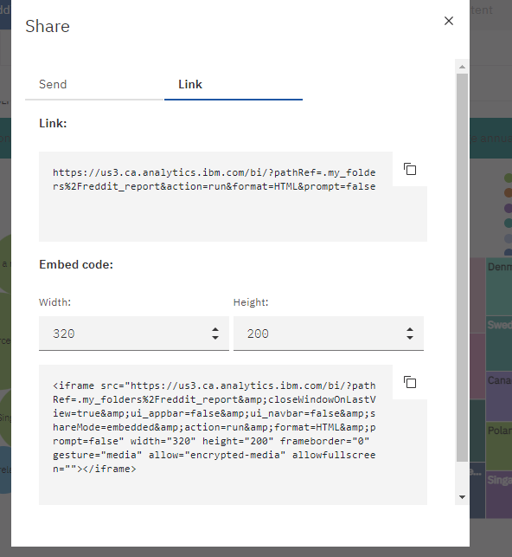

 Copy the’ Embed code’

Note: You can also change the width and height of the dashboard/story/report as you like.

**Dashboard,Report And Story Embed With UI With Flask**

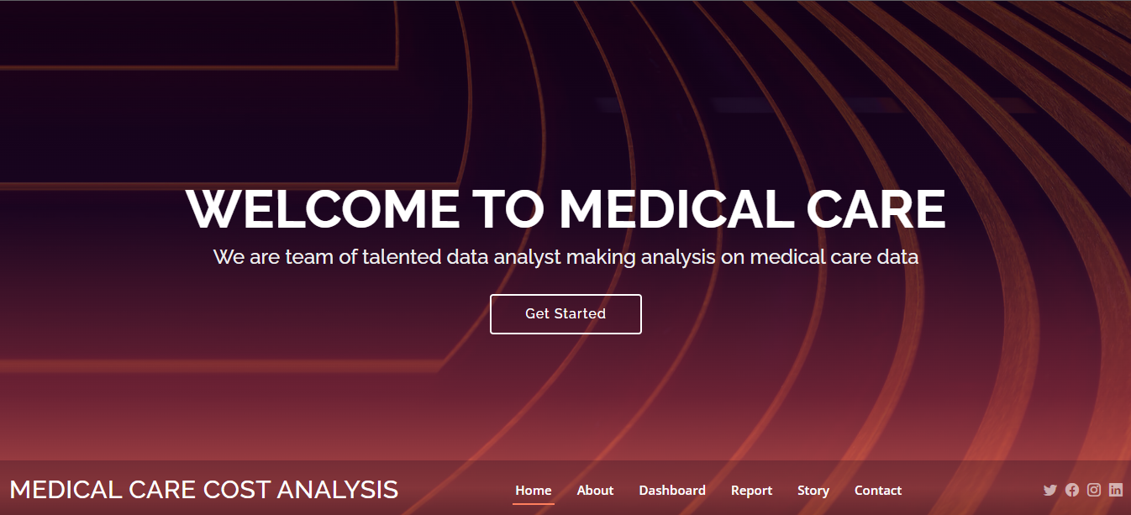

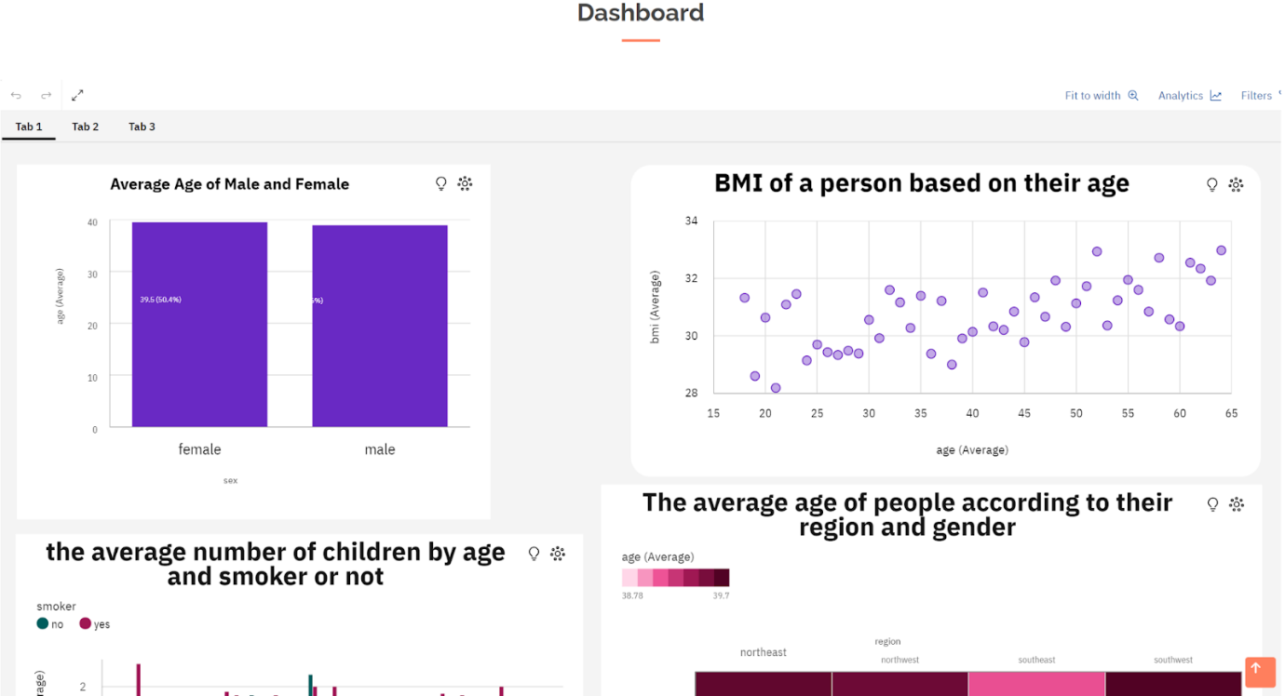

**CONCLUSION**

The "Estimation and Prediction of Hospitalization and Medical Care Costs" website aims to provide valuable insights to individuals, healthcare professionals, and institutions by offering accurate cost estimations and predictions for hospitalization and medical care expenses. Through this platform, users can make informed decisions, plan for potential medical expenses, and optimize their healthcare choices based on the estimated costs.

In conclusion, the "Estimation and Prediction of Hospitalization and Medical Care Costs" website serves as a valuable tool for individuals and healthcare stakeholders to make informed decisions about healthcare expenses. By providing reliable cost estimates and predictions, the platform contributes to better financial planning, resource allocation, and overall healthcare management.